**OUTREACH SCHOOLS EXAMINATION BOARD**

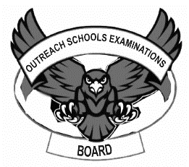 **END OF TERM II EXAMINATION 2024**

**TOP CLASS: (5 – 6 YEARS)**

**LEARNING AREA 1: SOCIAL DEVELOPMENT**

**My name is: ………………………………..………………………….**

**My School is: ……………………………..……….…………………..**

**I am in: ………………………………..…………………………………………..**

1. **Oral.**
2. Where do you go to school?
3. Who heads a school?
4. What is the name of your school?
5. Do you have a home?
6. What does a mother do at home?
7. How many dustbins do you have at school?
8. Recite numbers 1 – 10.
9. Please count your toes.
10. **Read and draw these activities.**

|  |  |  |
| --- | --- | --- |
| dancing | sweeping | walking |
|  |  |  |
| standing | reading | playing |
|  |  |  |

1. **Shade the biggest heart.**
2. **Circle the same words.**

builder builder singer

police policeman policeman

Uganda Buganda Uganda

station station share

driver sheikh driver

mama Imam Imam

1. **Read and draw people who protect and care for us.**

**farmer**

**teacher**

**END**